**Course Project   
DeVry University  
College of Engineering and Information Sciences**

***Screenshot of program running:***

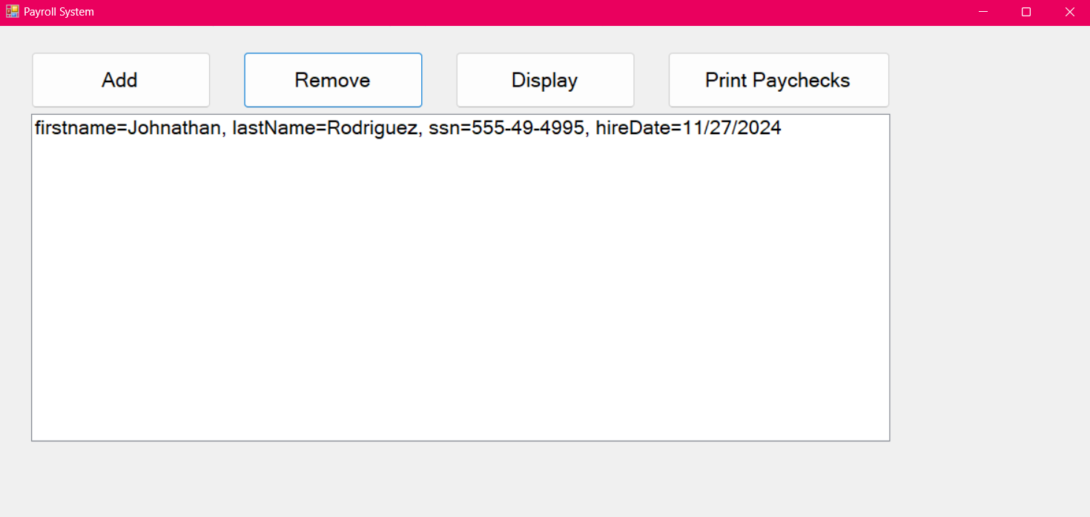

***Form code (only the code for the form and classes, not program.cs):***

using System;

using System.Collections.Generic;

using System.ComponentModel;

using System.Data;

using System.Drawing;

using System.IO;

using System.Linq;

using System.Text;

using System.Threading.Tasks;

using System.Windows.Forms;

namespace Rodriguez_CourseProject_Part2

{

public partial class PayrollButton : Form

{

private object sr;

private object parts;

public PayrollButton()

{

InitializeComponent();

}

private void Form1_Load(object sender, EventArgs e)

{

}

private void AddButton_Click(object sender, EventArgs e)

{

// add item to the Employee listbox

InputForm frmInput = new InputForm();

using (frmInput)

{

DialogResult result = frmInput.ShowDialog();

// see if the input form was cancelled

if (result == DialogResult.Cancel)

return; // end the method since cancelled

// get user's input and create Employee object

string fName = frmInput.FirstNameTextBox.Text;

string lName = frmInput.LastNameTextBox.Text;

string ssn = frmInput.SSNTextBox.Text;

string date = frmInput.HireDateTextBox.Text;

DateTime hireDate = DateTime.Parse(date);

Employee emp = new Employee(fName, lName, ssn, hireDate);

// add the Employee object to the Employee listbox

EmployeesListBox.Items.Add(emp);

// write all date to the file

WriteEmpsToFile();

}

}

private void WriteEmpsToFile()

{

string filename = "Employees.csv";

StreamWriter sw = new StreamWriter(filename);

foreach (Employee emp in EmployeesListBox.Items)

{

sw.WriteLine(emp.FirstName + ','

+ emp.LastName + ','

+ emp.SSN + ','

+ emp.HireDate.ToShortDateString());

}

sw.Close();

}

private void RemoveButton_Click(object sender, EventArgs e)

{

// remove the selected item from the employee listbox

int itemNumber = EmployeesListBox.SelectedIndex;

if (itemNumber > -1)

{

EmployeesListBox.Items.RemoveAt(itemNumber);

WriteEmpsToFile();

}

else

{

MessageBox.Show("Please select employee to remove.");

}

}

private void DisplayButton_Click(object sender, EventArgs e)

{

// clear the Employee listbox

EmployeesListBox.Items.Clear();

// read employees from the file

string filename = "Employees.csv";

StreamReader sr = new StreamReader(filename);

while( sr.Peek() > -1 )

{

string line = sr.ReadLine();

string[] parts = line.Split(',');

string firstName = parts[0];

string lastName = parts[1];

string ssn = parts[2];

DateTime hireDate = DateTime.Parse(parts[3]);

Employee emp = new Employee(firstName, lastName, ssn, hireDate);

EmployeesListBox.Items.Add(emp);

}

sr.Close();

}

private void PrintPaychecksButton_Click(object sender, EventArgs e)

{

MessageBox.Show("Printing paychecks for all employees...");

}

}

}